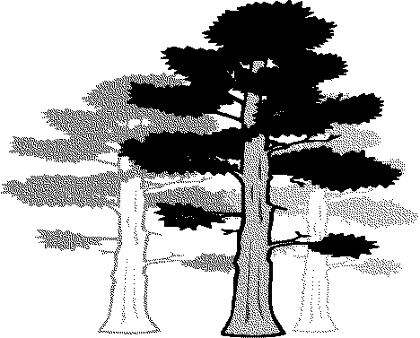

**Colinton Surgery**

**Bladder Diary**

**Keeping a bladder diary to keep track of your daily urinary habits can help your healthcare professional better understand your symptoms of a sensitive bladder. It might find out the causes of your bladder control and help you get the right treatment to manage your condition.**

**This three day diary will give a picture of how your bladder is working and an**

**idea of your fluid intake, the amount of urine your bladder can hold and how often you pass urine.**

**Completing the Diary**

Fill the bladder diary in for **three days** as carefully as possible. For each day record the following.

**How much you drink and when**

Each time you have a drink, make a note of how much to drink and at what time. It may help to measure how many ml a mug or cup holds before you begin making it easier to log your fluid intake. Fluids include water, coffee, tea, juice and alcohol.

**Urination**

Before you begin buy a small measuring jug to help measure your urine output. Each time you go to the toilet record how much urine you passed and when, noting whether you had a sudden urge to pee or not. Also record the time you pass urine at night. At times, such as when you're out shopping, when it is not possible measure the amount, tick the 'urine passed' column to show that you have passed urine.

**Leakage**

Record any wet episodes and making note of the reason using this key:

**A -** Coughed, sneezed, movement, exercise

**B -** Did not make it to the toilet in time

**C -** Unsure, do not know

**D** - Other reason

**Bladder Diary**

**Name:**

**DOB:**

**GP:**



|  |  |  |  |  |  |
| --- | --- | --- | --- | --- | --- |
| **Day 1** | | | | | |
| **Time** | **Fluids In** | **Urination** | | **Leakage** | |
| **How much did you drink** | **Urine passed (ml)** | **Sudden strong urge to pass (Y or N)** | **Did you leak**  **(please tick)** | **Why did you leak (see page 1)** |
| ***eg. 11.00am*** | ***150ml*** | ***100ml*** | ***Yes*** | ***√*** | ***B*** |
|  |  |  |  |  |  |
|  |  |  |  |  |  |
|  |  |  |  |  |  |
|  |  |  |  |  |  |
|  |  |  |  |  |  |
|  |  |  |  |  |  |
|  |  |  |  |  |  |
|  |  |  |  |  |  |
|  |  |  |  |  |  |
|  |  |  |  |  |  |
|  |  |  |  |  |  |
|  |  |  |  |  |  |
|  |  |  |  |  |  |
|  |  |  |  |  |  |
|  |  |  |  |  |  |
|  |  |  |  |  |  |
|  |  |  |  |  |  |

**Bladder Diary**

**Name:**

**DOB:**

**GP:**



|  |  |  |  |  |  |
| --- | --- | --- | --- | --- | --- |
| **Day 2** | | | | | |
| **Time** | **Fluids In** | **Urination** | | **Leakage** | |
| **How much did you drink** | **Urine passed (ml)** | **Sudden strong urge to pass** | **Did you leak**  **(please tick)** | **Why did you leak (see page 1)** |
| ***eg. 11.00am*** | ***150ml*** | ***100ml*** | ***Yes*** | ***√*** | ***B*** |
|  |  |  |  |  |  |
|  |  |  |  |  |  |
|  |  |  |  |  |  |
|  |  |  |  |  |  |
|  |  |  |  |  |  |
|  |  |  |  |  |  |
|  |  |  |  |  |  |
|  |  |  |  |  |  |
|  |  |  |  |  |  |
|  |  |  |  |  |  |
|  |  |  |  |  |  |
|  |  |  |  |  |  |
|  |  |  |  |  |  |
|  |  |  |  |  |  |
|  |  |  |  |  |  |
|  |  |  |  |  |  |
|  |  |  |  |  |  |



**Bladder Diary**

**Name:**

**DOB:**

**GP:**

|  |  |  |  |  |  |
| --- | --- | --- | --- | --- | --- |
| **Day 3** | | | | | |
| **Time** | **Fluids In** | **Urination** | | **Leakage** | |
| **How much did you drink** | **Urine passed (ml)** | **Sudden strong urge to pass** | **Did you leak**  **(please tick)** | **Why did you leak (see page 1)** |
| ***eg. 11.00am*** | ***150ml*** | ***100ml*** | ***Yes*** | ***√*** | ***B*** |
|  |  |  |  |  |  |
|  |  |  |  |  |  |
|  |  |  |  |  |  |
|  |  |  |  |  |  |
|  |  |  |  |  |  |
|  |  |  |  |  |  |
|  |  |  |  |  |  |
|  |  |  |  |  |  |
|  |  |  |  |  |  |
|  |  |  |  |  |  |
|  |  |  |  |  |  |
|  |  |  |  |  |  |
|  |  |  |  |  |  |
|  |  |  |  |  |  |
|  |  |  |  |  |  |
|  |  |  |  |  |  |
|  |  |  |  |  |  |